Post lab
- Create a stored procedure called “SP_NewEmployeeDetail” which should insert the following details from Employee table in to a new table “T_EmployeeDetail” .The table can be manually created with the selection of following attributes.

EmployeeSSN, Name, salary, Address

create table T_EmployeeDetail
(
EmployeeSSN varchar(9),
Name varchar(30),
salary int,
Address varchar(200)
)

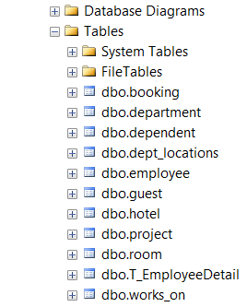

create procedure SP_NewEmployeeDetail
as
insert into T_EmployeeDetail
select e.ssn, e.fname + ' ' + e.Lname, e.salary, e.address
from employee e

SP_NewEmployeeDetail
select * from T_EmployeeDetail

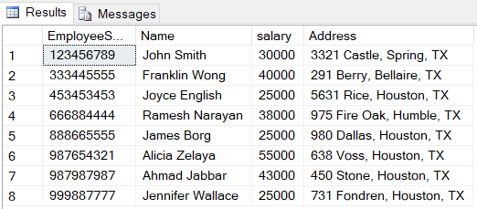
- Create a stored procedure that returns the maximum salary earner of the department whose name is given as parameter.

create procedure GetMaxSalaryEarner @departmentName varchar(50) = NULL, @earnerName varchar(50) output
as
select @earnerName = (e.fname + ' ' + e.Lname)
from employee e inner join department d on e.Dno = d.Dnumber
where (d.Dname = @departmentName) and e.salary =
(
select max(e1.depSalary)
from
(
select e2.salary depSalary
from employee e2 inner join department d on e2.Dno = d.Dnumber
where d.Dname = @departmentName
) e1
)

declare @eName varchar(50)
exec GetMaxSalaryEarner 'Research', @eName output
select @eName Name

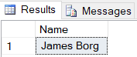

declare @eName varchar(50)
exec GetMaxSalaryEarner 'Headquarters', @eName output
select @eName Name

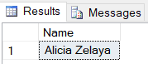

declare @eName varchar(50)
exec GetMaxSalaryEarner 'Administration', @eName output
select @eName Name

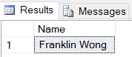

declare @eName varchar(50)
exec GetMaxSalaryEarner 'Accounts', @eName output
select @eName Name

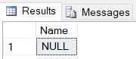

- Create a view that displays the name and salary of the employee who is working on the maximum number of projects.

create view EmployeeView
as
(
select e.fname + ' ' + e.Lname Name, e.salary
from employee e inner join works_on w on e.ssn = w.essn
group by w.essn, e.fname, e.Lname, e.salary
having count(w.Pno) =
(
select max(w1.projectCount)
from
(
select w2.essn, count (w2.Pno) projectCount
from works_on w2
group by w2.essn
) w1
)
)

select * from EmployeeView

